Why hibernate :

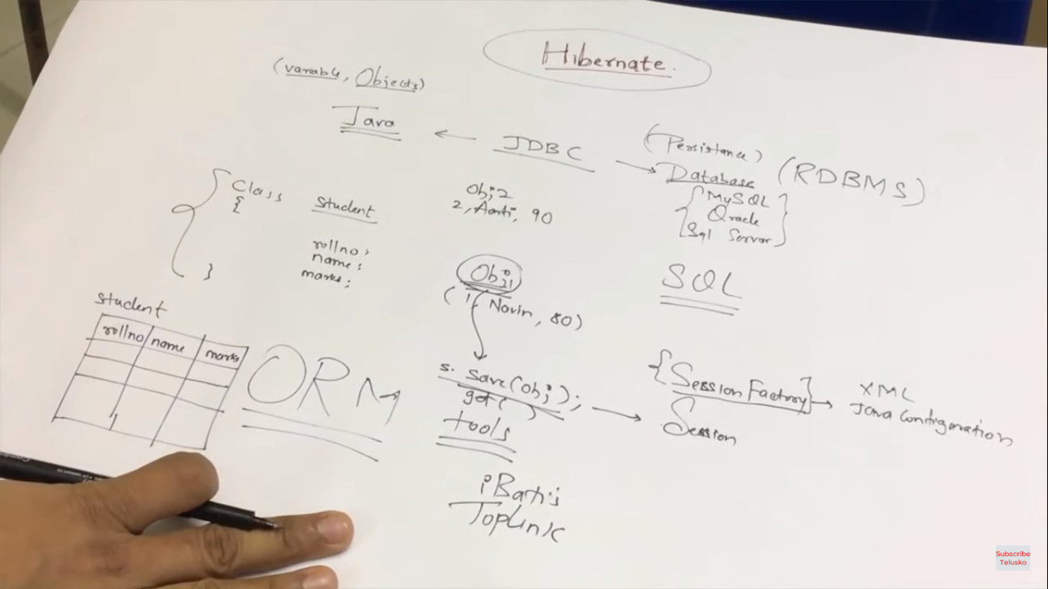

Example: (implemetation)

* Select maven prioject
* 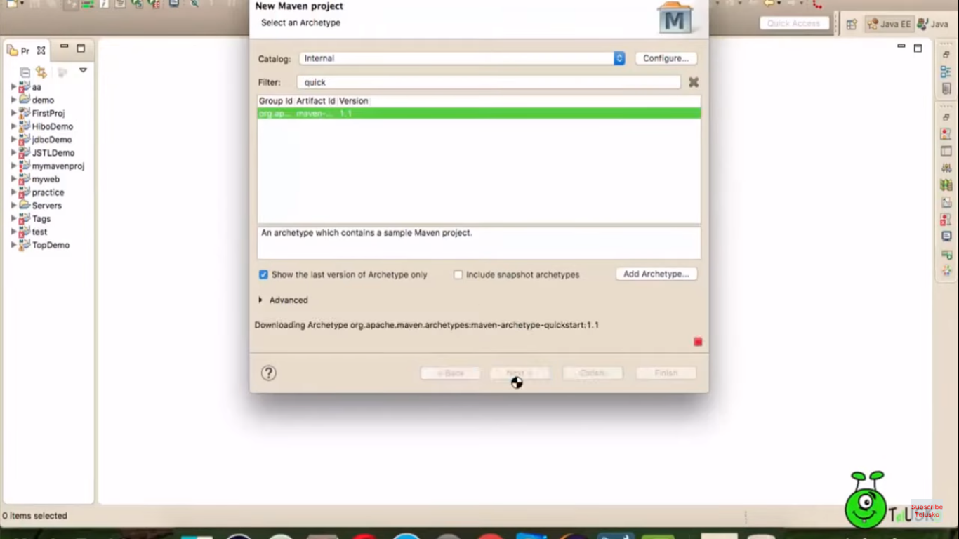
* 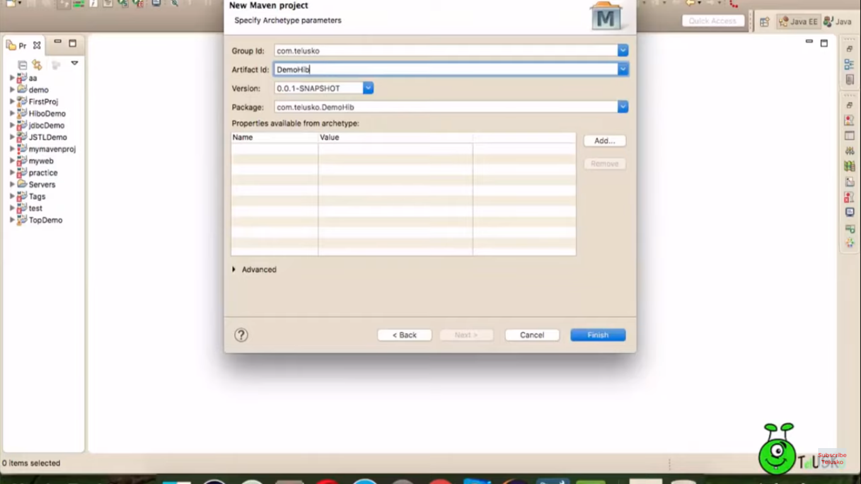
* 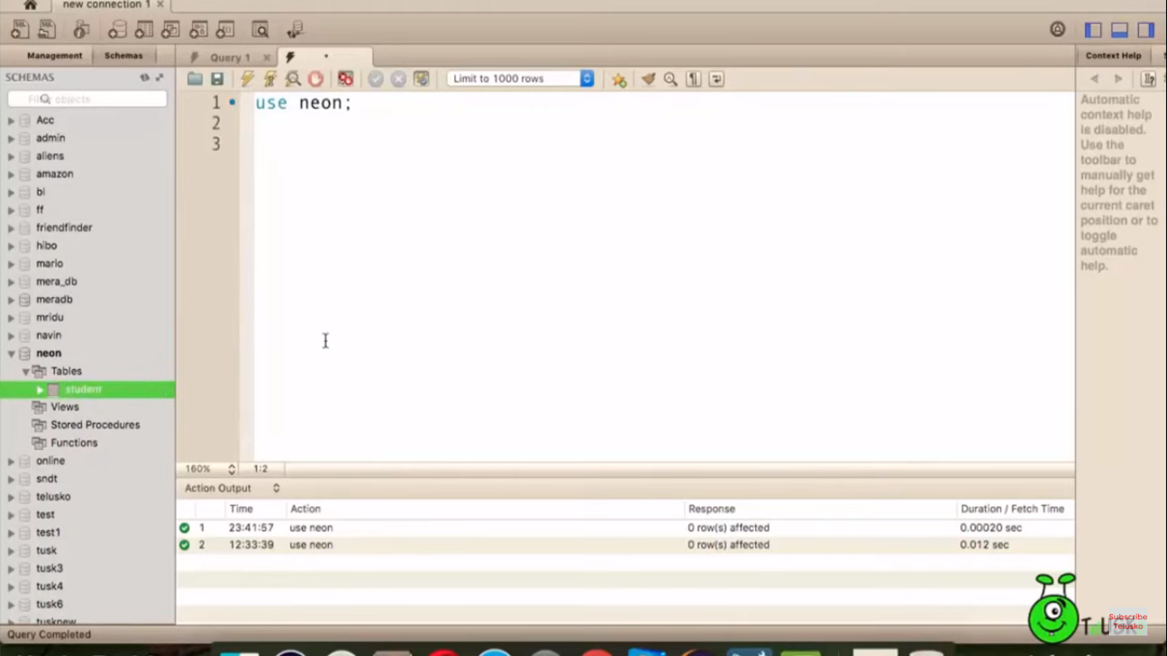
* 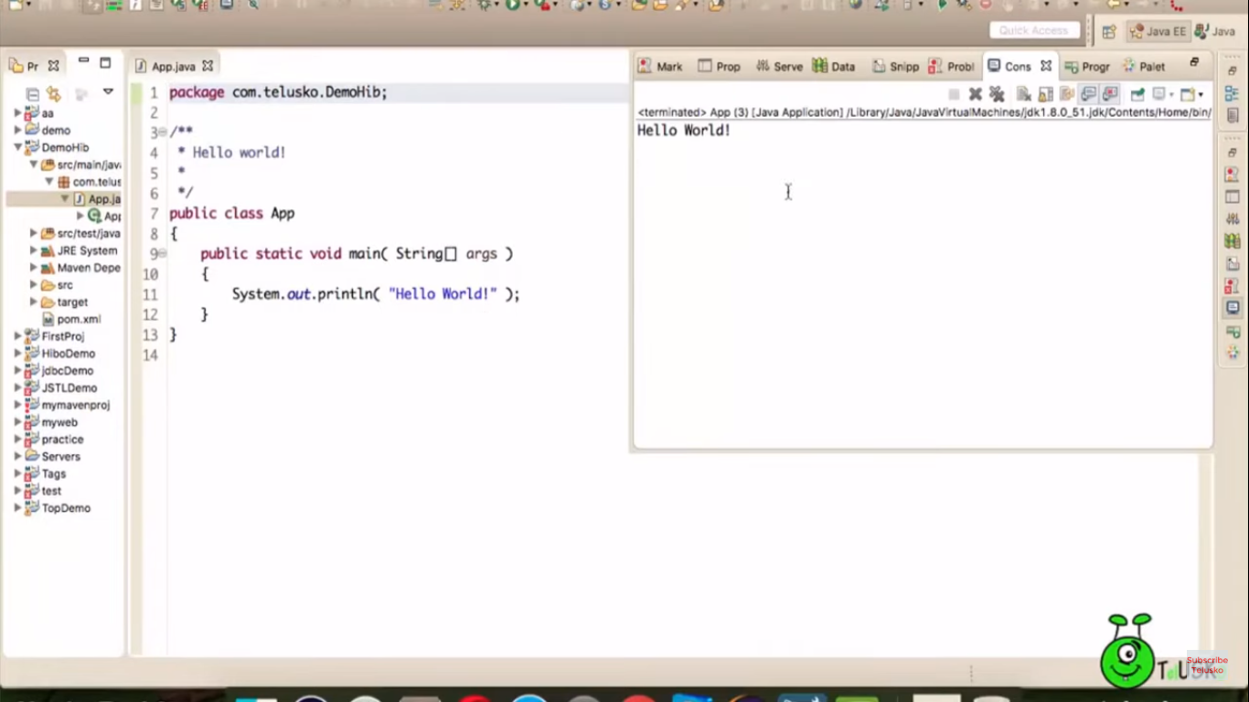
* 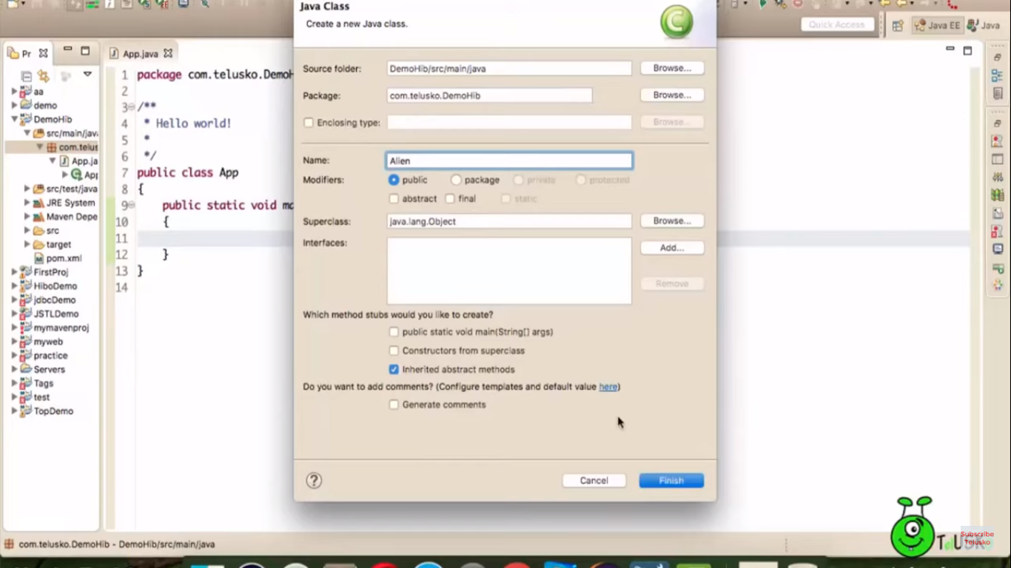
* Defining structure in above class
* 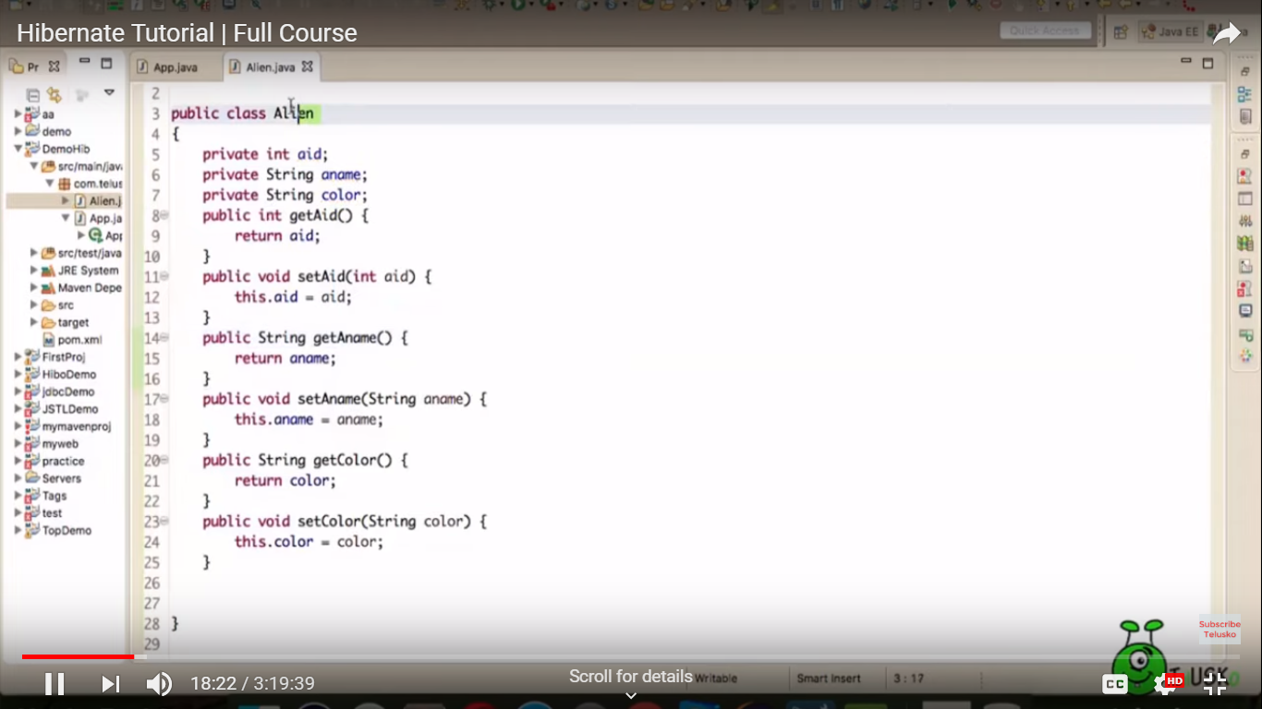
* main class implantation
* before that add dependencies in pom.xml (2 configurations hibernate & mysql)
* 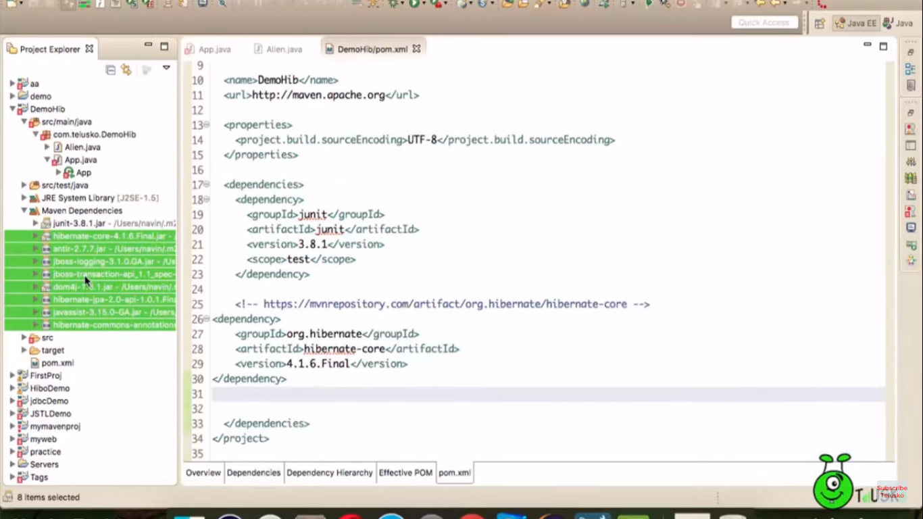
* 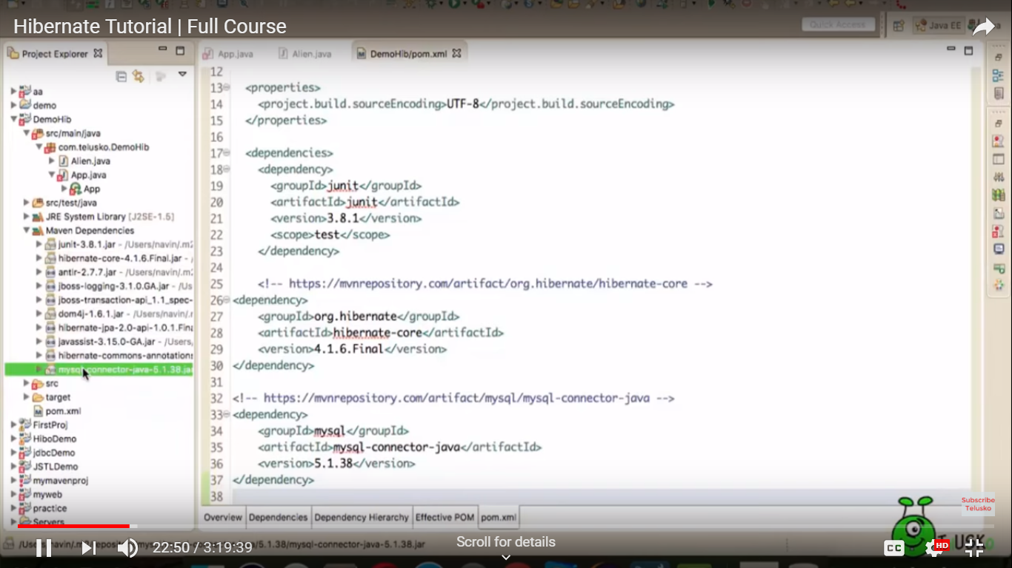
* 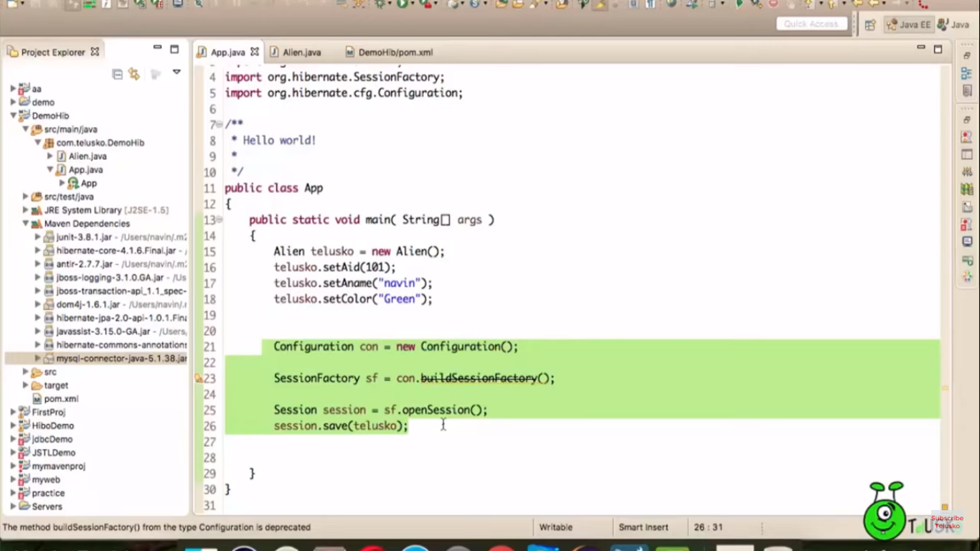
* 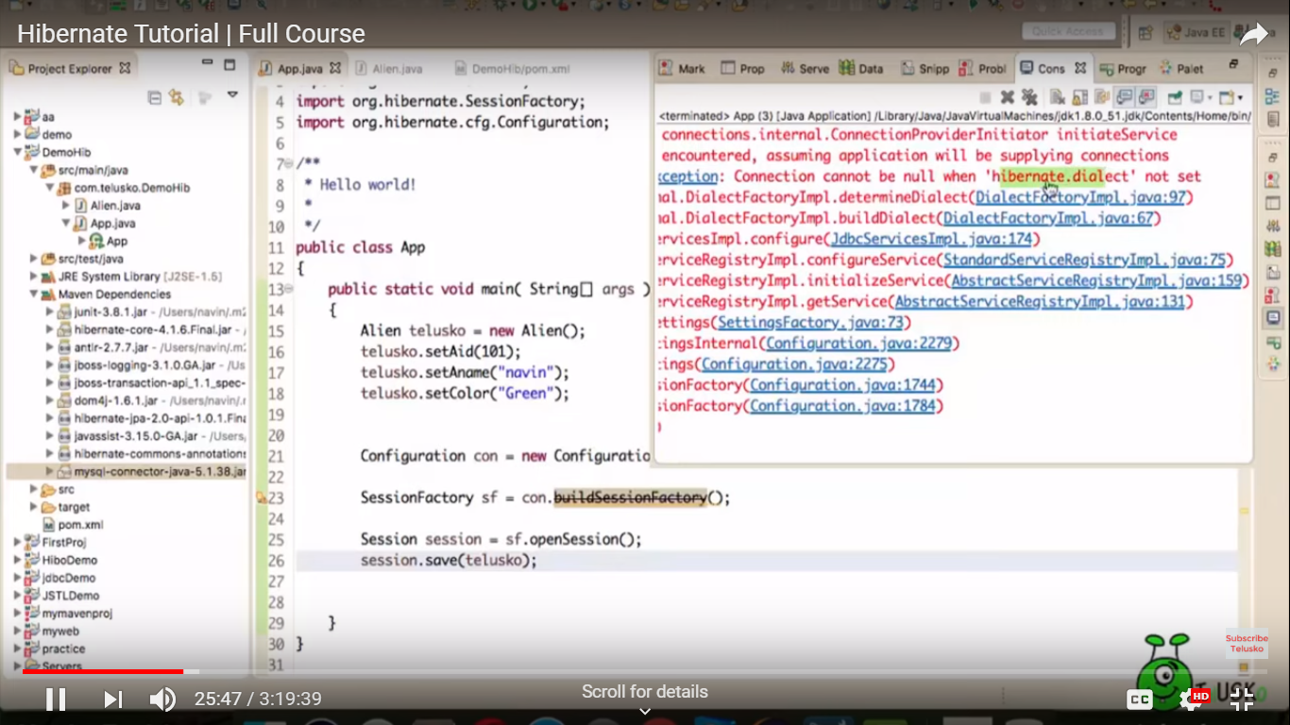
* In above screenshot error relates to connection parameters not specified. So a configuration hibernate.cfg.xml need to be creates in project. Before this step configure hibernet in eclipse
* 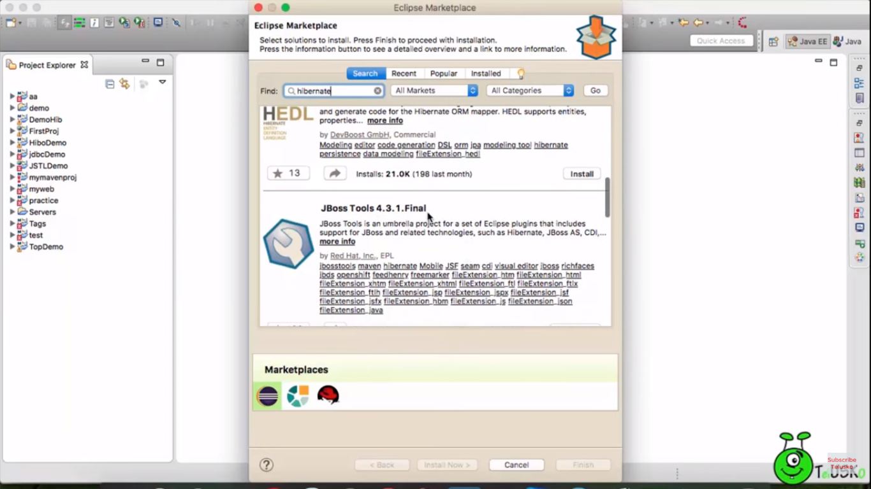
* 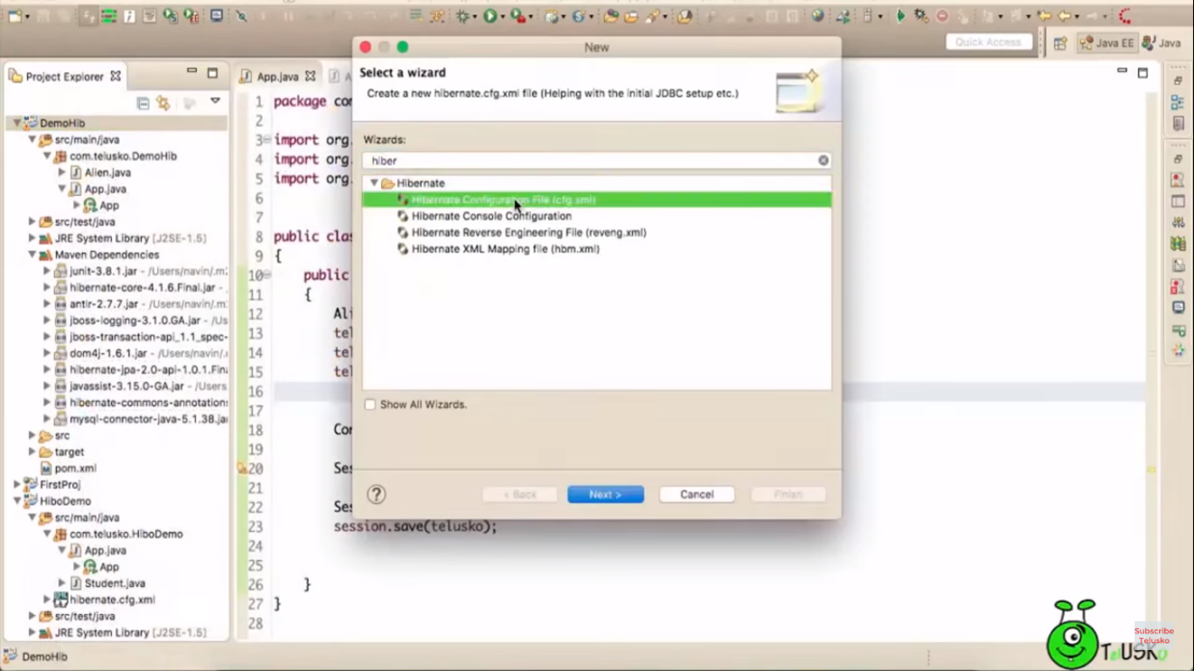
* 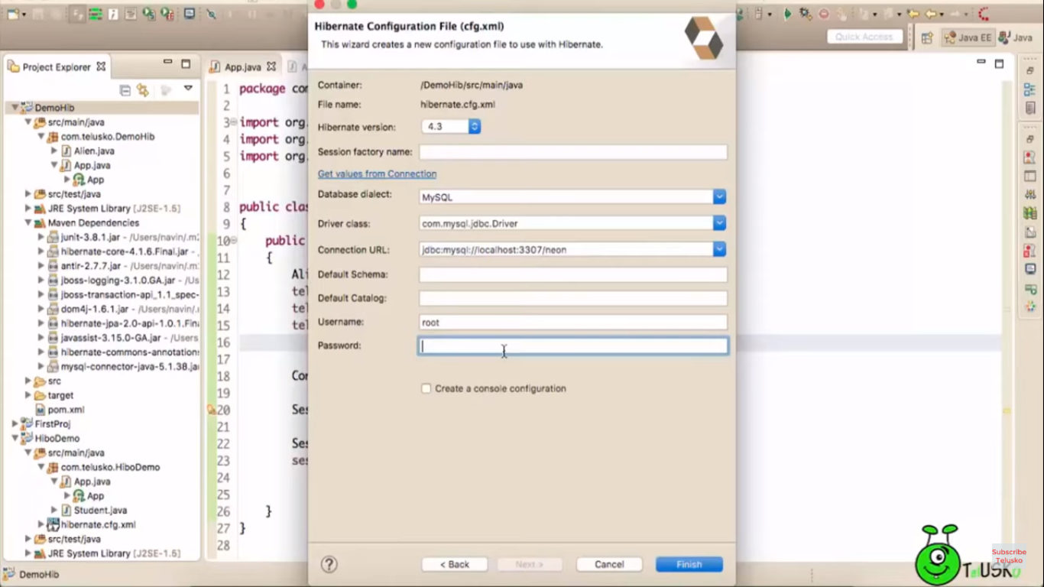
* 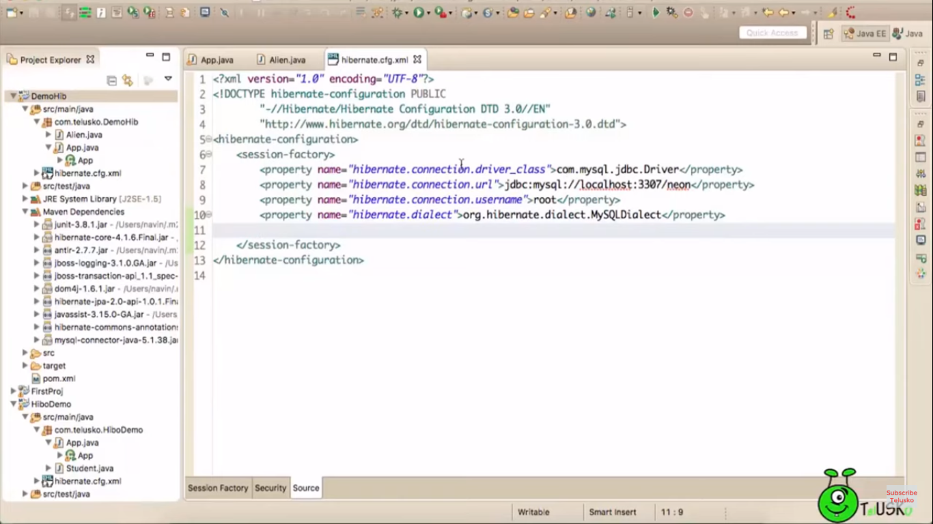
* 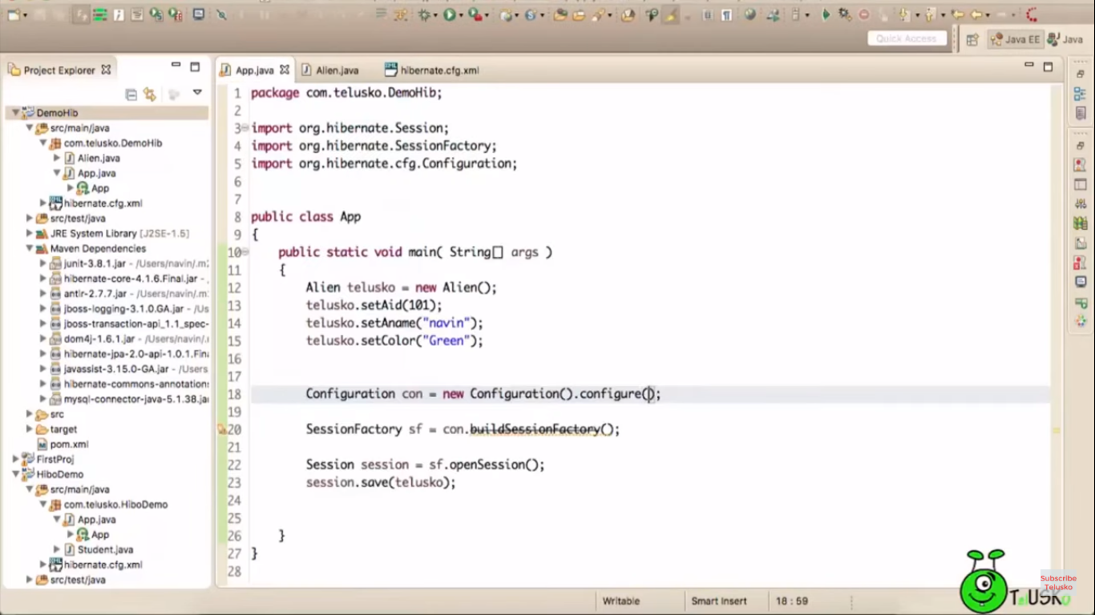
* In configure mention the name of the hibernate xml config file if it is not default(hibernate.cfg.xml) .
* 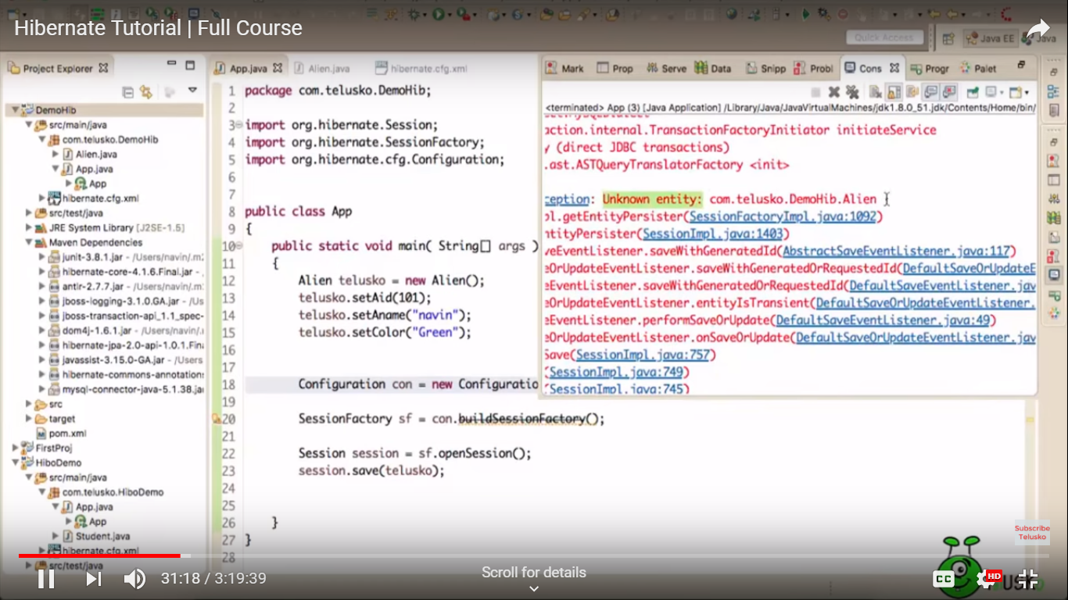
* @Entity
* 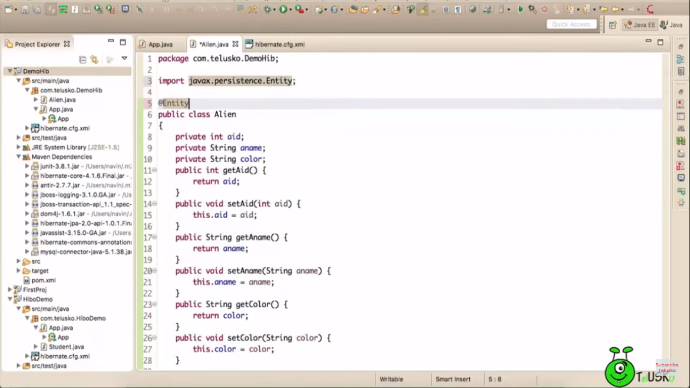
* Declaring class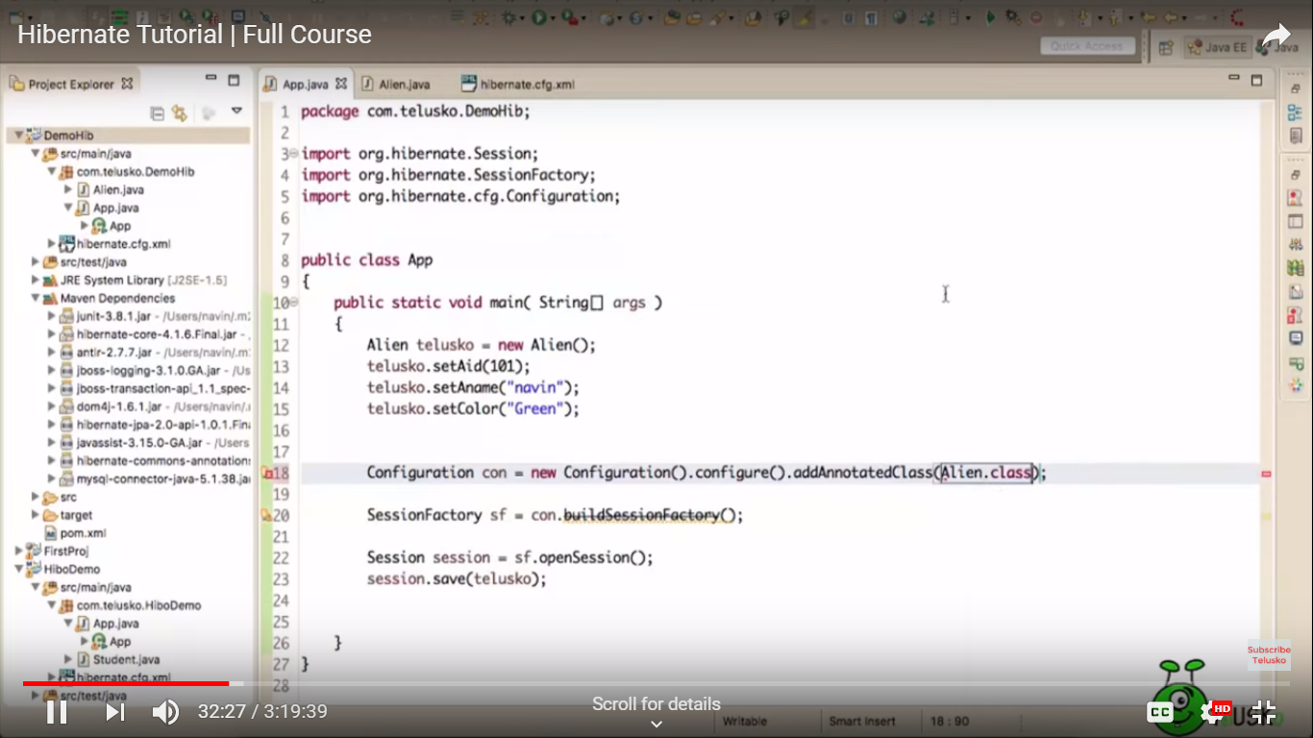
* 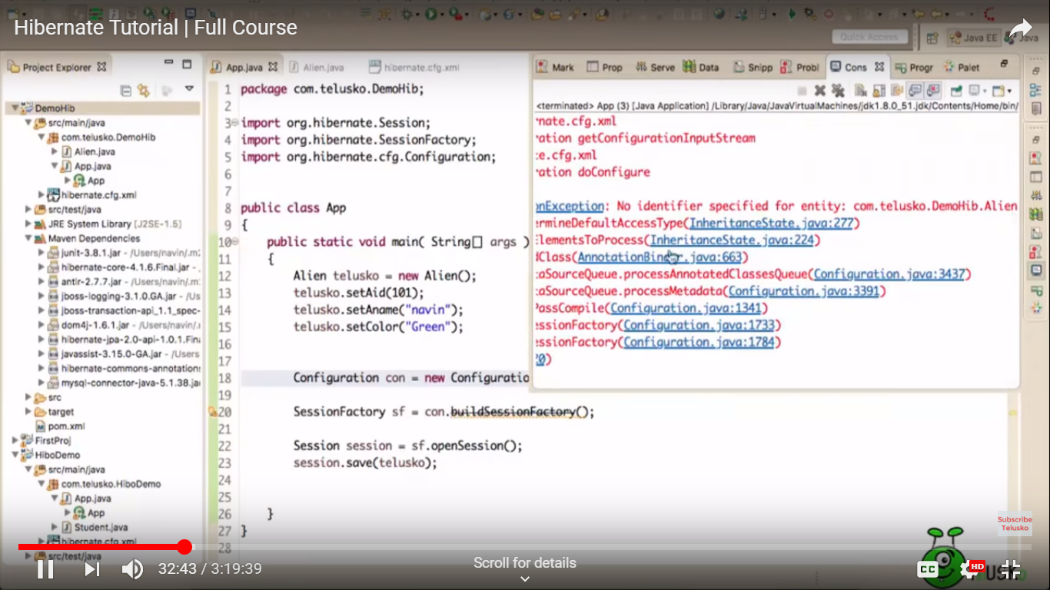
* Declare primary key (@Id)
* 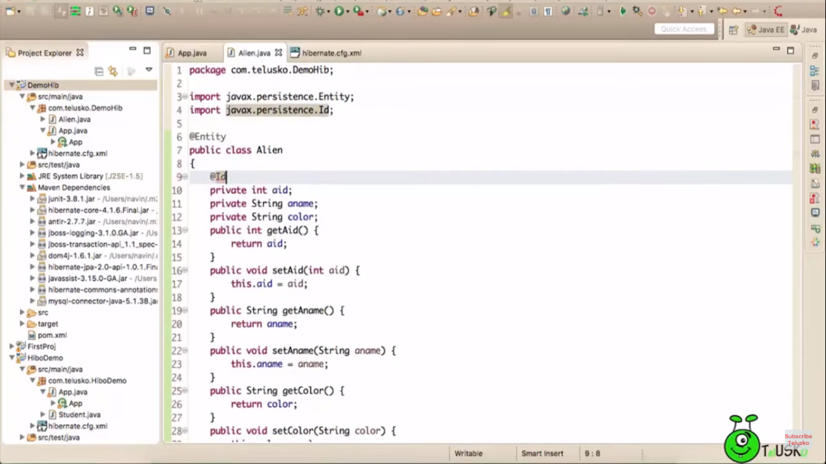
* Declaring transcation and commit()
* 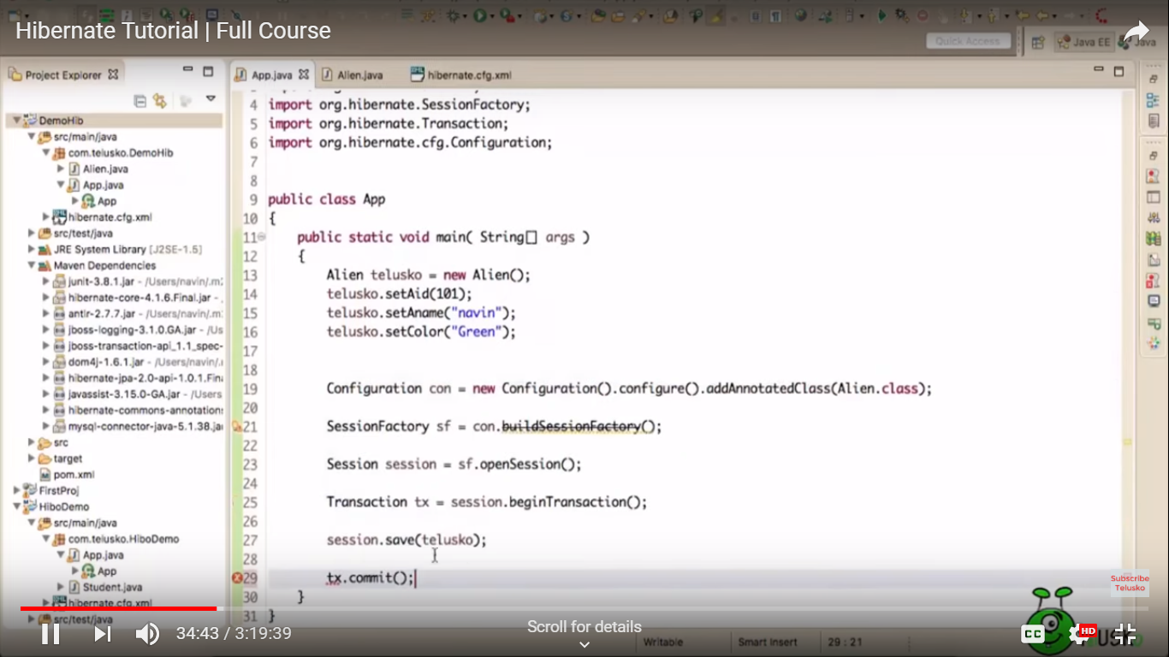
* No table neon.entity🡪create a table (under hibernate.cfg.xml via property )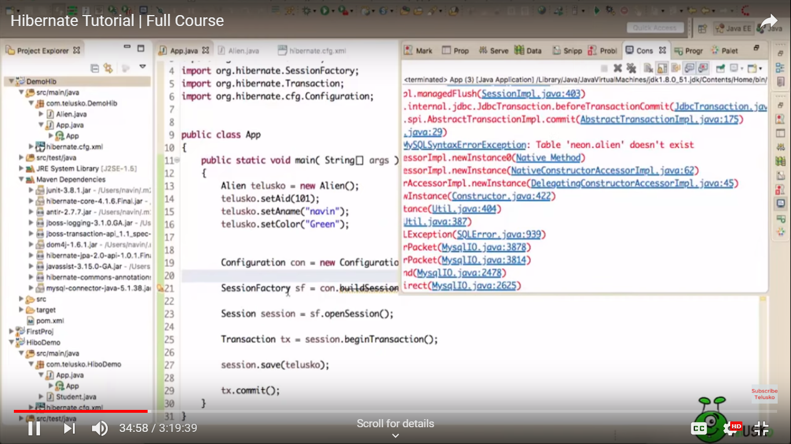
* Created a property 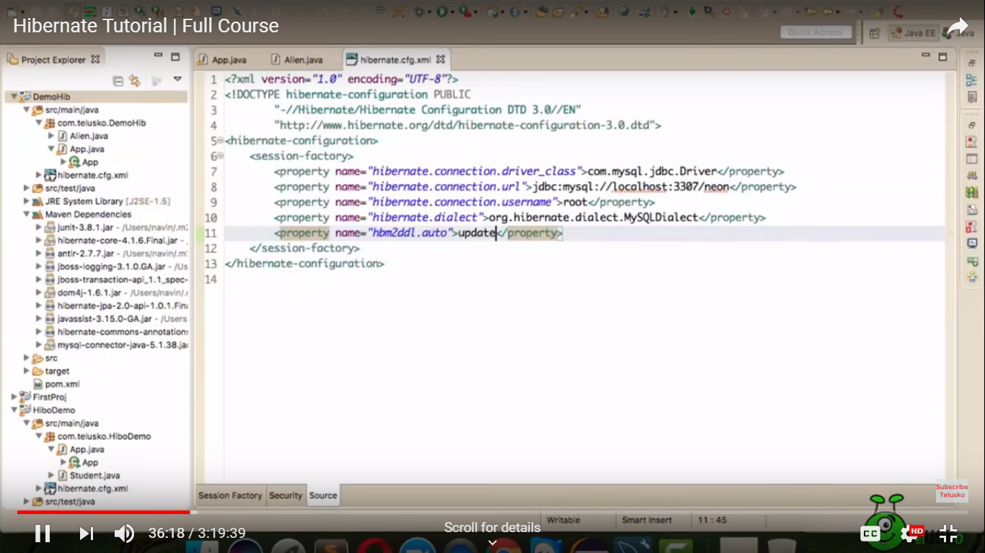
* Now table created 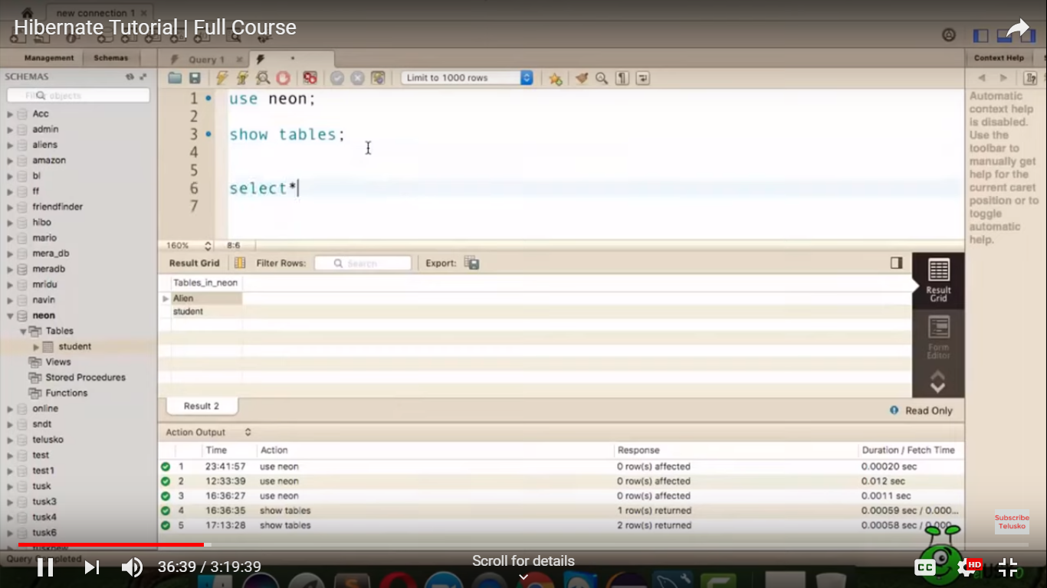
* Final program : but(remove deprecated method)🡪 add ServiceRegistry from org.hibernate.* 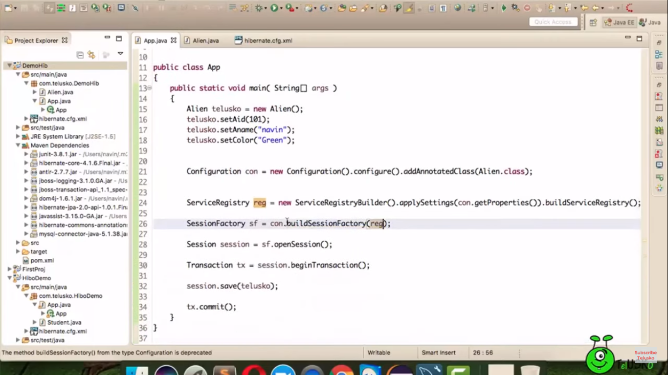
* Log says (Schema update complete) post execution.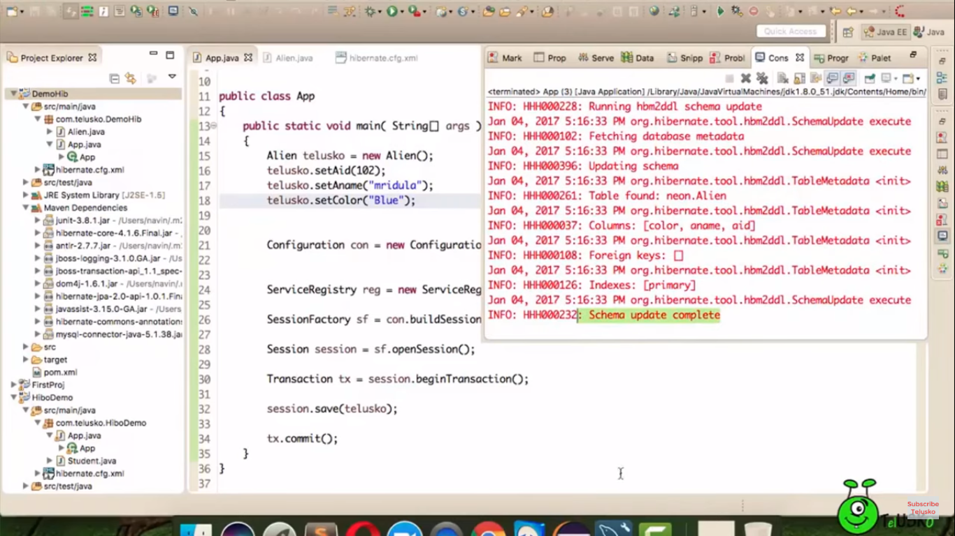
* If we user create in cfg.xml🡪 for every run it will create new table by deleting the old table with same name.
* If we user update in cfg.xml🡪 for every run it will update the existing table.
* See the query in log🡪 add below property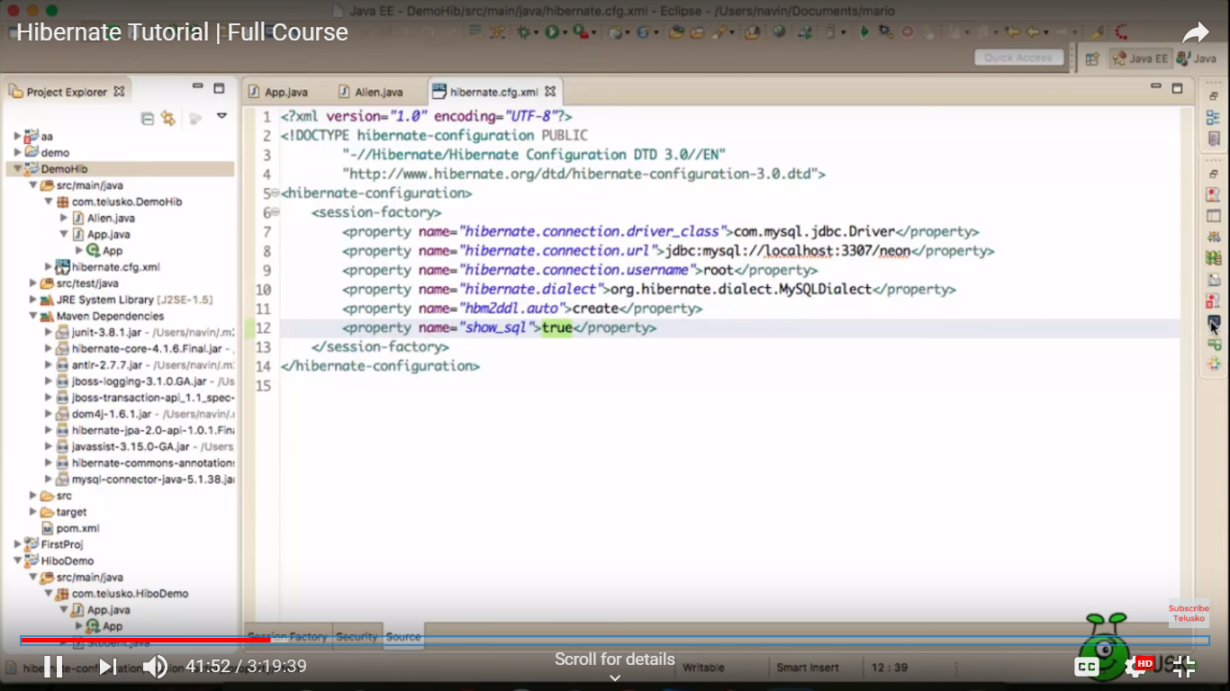

Annotations :

1. @Entity(name=”table_name”) 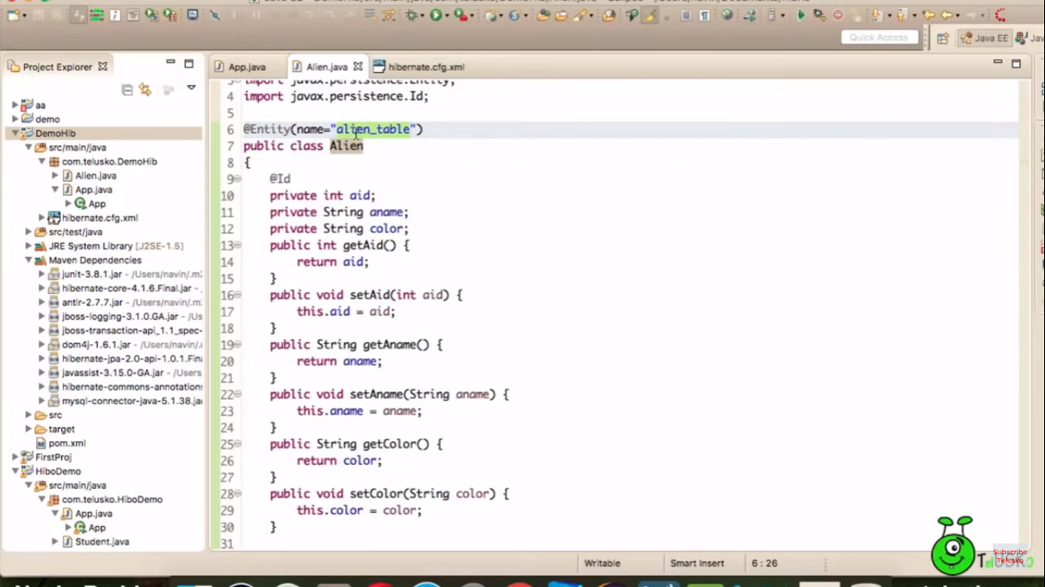
2. @Table(name=”table_name”) 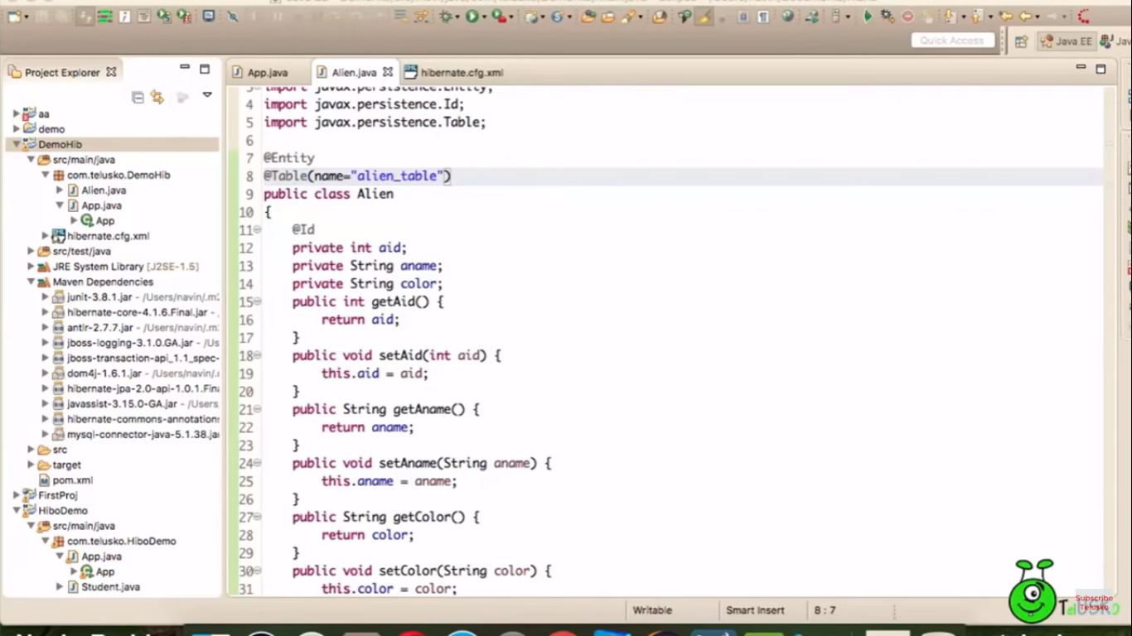
3. @Column(name=”alien_color”) 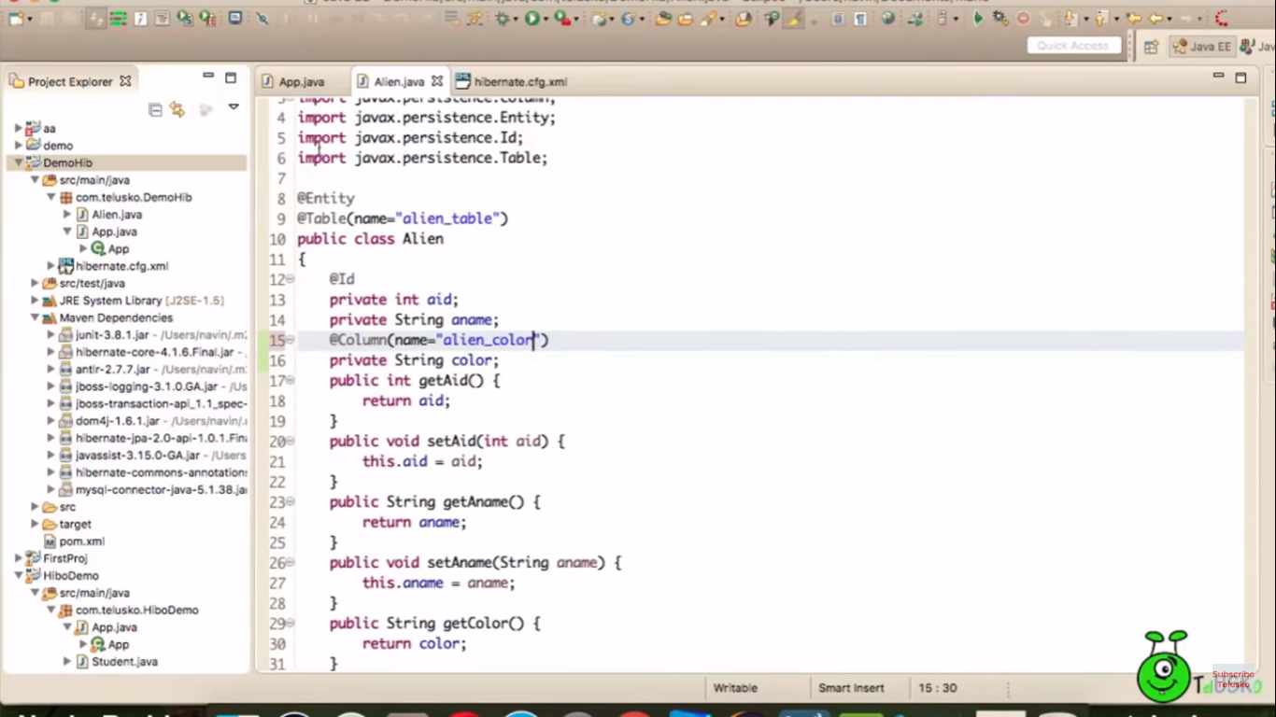
4. @Transient (ignore column while storing)